Unreal Collisions

1. Create a Twin Stick shooter
2. Show different types of collisions on playing the game
3. There are 3 types of collision responses
   1. Block – bocks but can have a response
   2. Overlap- objects can overlap and creates an event
   3. Ignore – overlaps and triggers no event
4. Go to game and select an object
5. Go to details panel and go to collision
6. Set the collision response to custom (it should be in default)
7. Expand collision preset and inspect
8. There are 2 types of Collision responses
   1. Trace Responses
   2. Object Responses
9. Select the pawn and select its static mesh expand its collision preset and inspect.
10. Go back and select the object and set the collision on pawn to overlap and see the difference in game
11. Explain collsion response matrix
12. 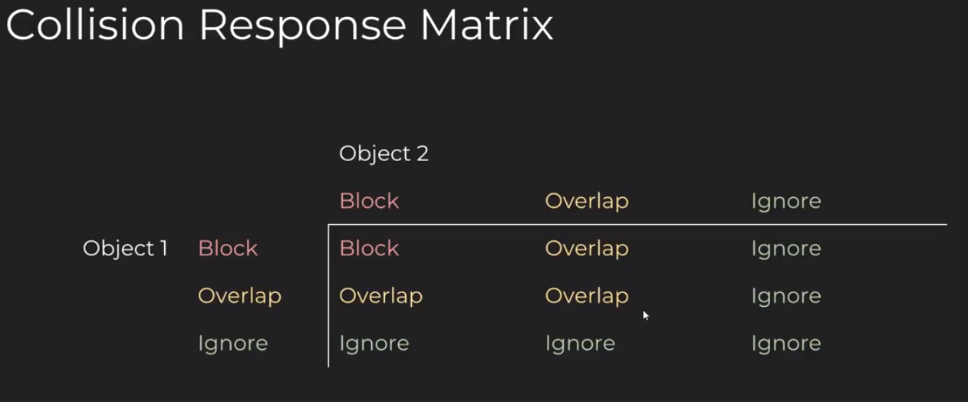
13. On the object set collision response of pawn to block and projectile to overlap
14. See the difference
15. Create a new object and give it a new material
16. Go to project settings and under Engine select collision
17. Expand presents and explore each preset (double click to open it)
18. Click new under preset to create a new preset.
19. Give a name “permeable Wall” and a description if needed
20. Check overlap for projectiles
21. On collision enabled there are 3 options
    1. Query Only (No physics collision) – can it see through
    2. Physics Only (No Query Collision) – can it be blocked
    3. Collision Enabled (Query and Physics) – both of the above
22. Select collision Enabled and
23. Accept.
24. 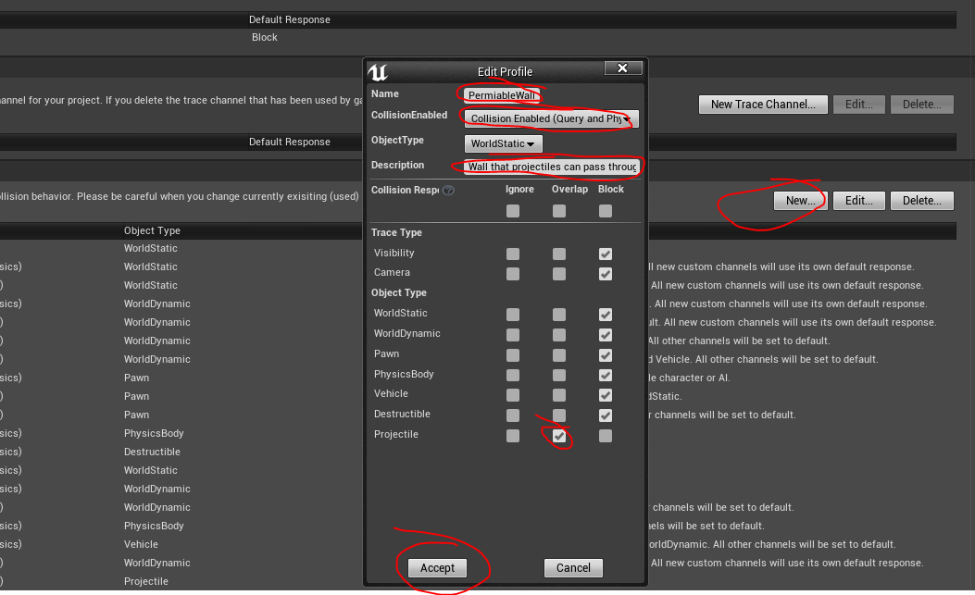
25. We made a preset where we should be able to shoot through the mesh but cannot pass through
26. Now lets make an AI enemy that can shoot player if it sees
27. Create an AIController Class
28. Set it as the AI controller of the TwinStickPawn in the class defaults.
29. Drag the TwinStickPawn to the world. (**Go to the world and Make sure the Enemy Pawn is above the floor**)
30. Try a PrintString on the begin play to see if it works
31. Now we need to do a line trace to find the enemy can see the player.
32. For that we need to add a function called LineTraceByChannel on event tick
33. 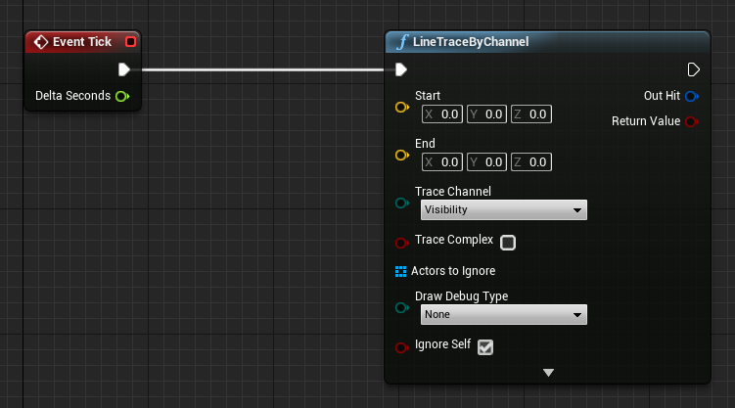
34. Now we need to determine if the line trace can pass through the objects or not
35. Select the new object we created, PermiableWall and trace channel in the collisions
36. 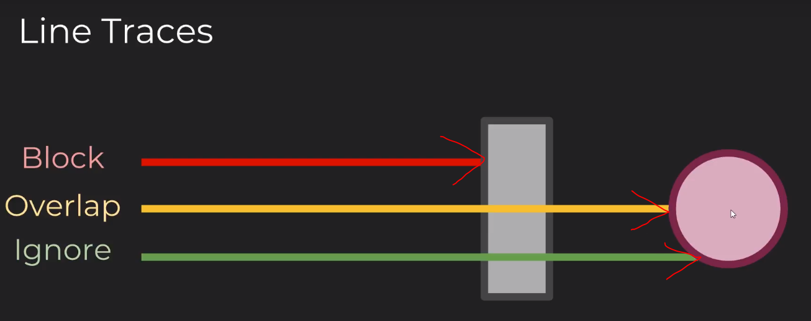
37. We can create a new trace channel for out object.
38. Go to project settings and select the collision under Engine.
39. Create new Trace channel as below.
40. 
41. Now go to the EnemyAIController and add the following BP (Make sure the Enemy Pawn is above the floor)
42. 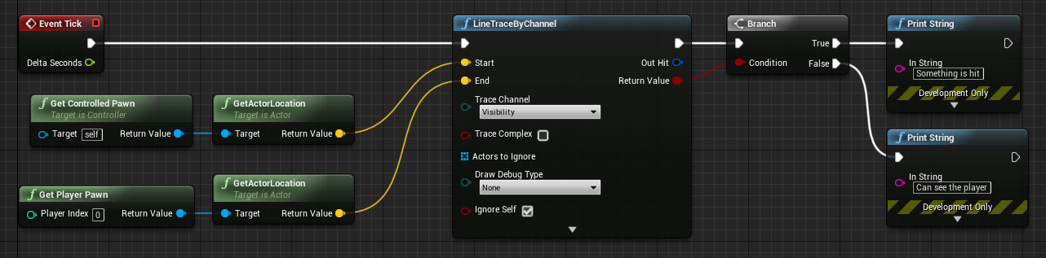
43. When we play we can find that when the line is broken by any object appropriate message is printed on the screen
44. Now we need to fire bullet when the enemy sees the player.
45. So create a function called Fire and add it instead of the printstring
46. In the Fire function add the following BP
47. 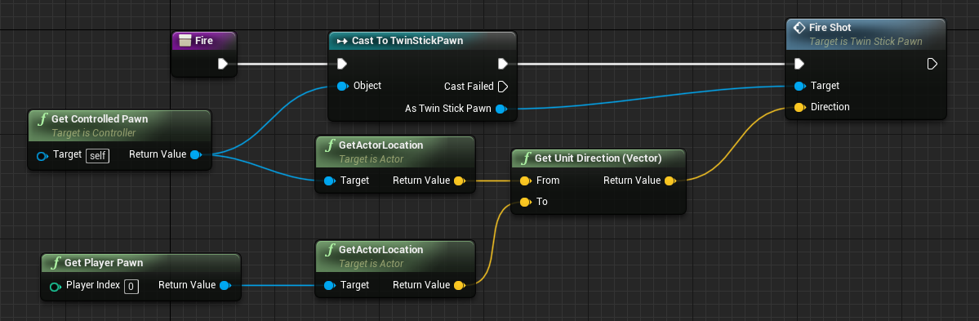
48. Add Fire function to the linetrace false pin of the branch.
49. The Enemy shoud be shooting at the player when we play the game.
50. We can shoot through the permiableWall because it overlaps the Projectile but line trace is blocked.
51. Now we need the enemy be able to shoot through the wall.
52. For that we go to the collsion preset ‘Permiable wall’ and choose shootable to be overlap
53. 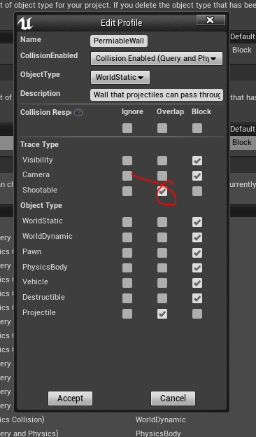
54. Now we need to select the trace channel in line trace
55. 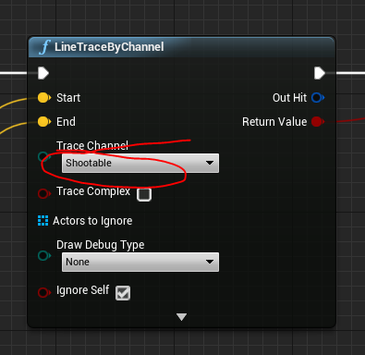
56. It will still need some works.
57. We can debug by printing the object the line hits. So split the out hit pin of LineTraceByChannel and add the following
58. 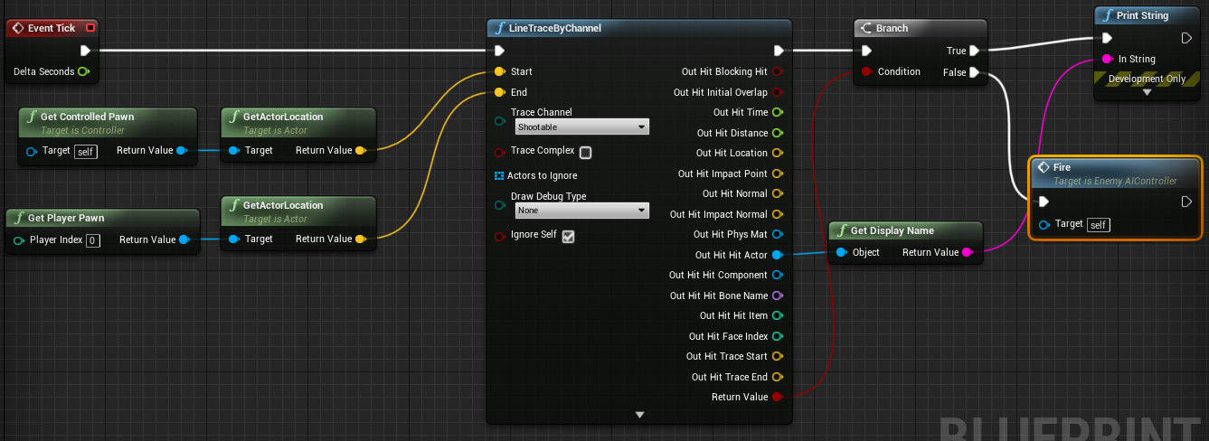
59. In the print string we can see that it is hitting itself.
60. So go to the presets in project settings and find the pawn
61. Set ignore for shootable
62. 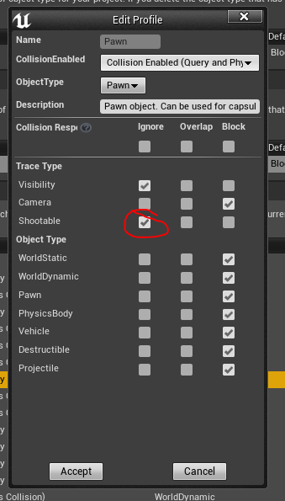
63. This should be able to make enemy shoot through the blue wall.
64. Tidy up the BP
65. Next part is Hit and Overlap Events
66. Basically sound for collision and overlap. (bullet pass through wall, bullet hit, pawn hit the wall etc…)
67. We want to trigger a hit event (**HIT EVENTS ARE TRIGGERED BY STATIC MESH)**
68. Go to the the twin stick pawn and
69. Select the static mesh (the ship) from the components or from the viewport
70. 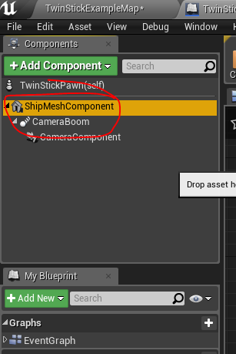
71. On the right side details panel in the bottom events we can select the events.
72. Select the ‘On Component Hit’
73. 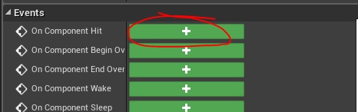
74. It will create an event in the event graph
75. Add the following BP
76. 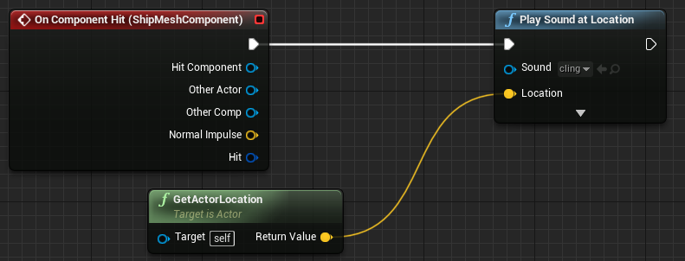
77. Now lets add sound to the Yellow blocks
78. Select it and click on the blue button (Blueprint/Add Script) indetails panel
79. 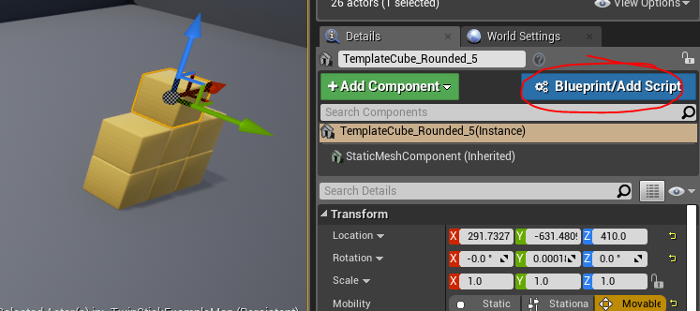
80. This will turn it into a Blueprint
81. Now do the same step what we did for the pawn.
    1. Select the mesh and add the On Component Hit event
    2. Add the following BP
    3. 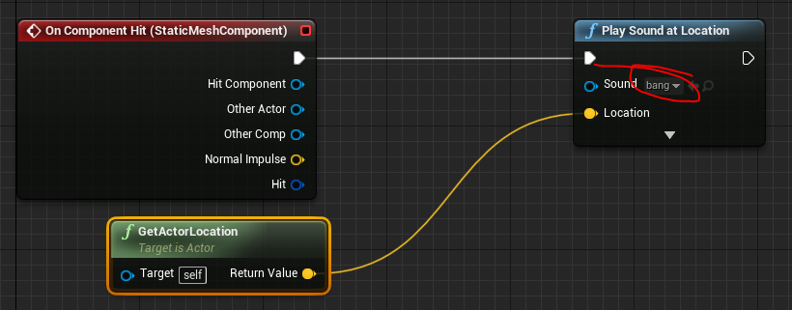
82. Now when you play we can notice that only the bullet hit will make the sound. When it falls off it is not creating sound. This is because the physics of the ball is not generating hit events.
83. To fix this select the mesh and on the details panel under collision there is an option to turn that on.
84. 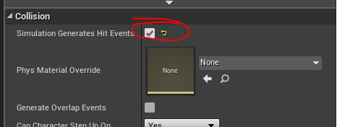
85. Now it generates hit event in all hits. It would be good if we can cutoff some sounds for small hits (like the box settling)
86. To do that edit the BP.
87. 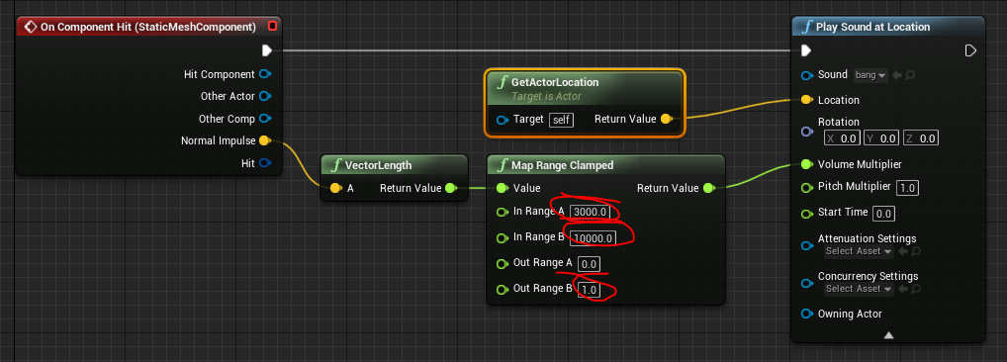
88. Vector length of the impulse value is taken and then that value is clamped relatively between 0 and 1. That is then applied as volume of the sound. This will eliminate sounds for all small hits.
89. Now we want to make a “swoosh” sound while the bullet goes through the permeable wall.
90. Let’s do this on the Projectile. So open it
91. Just like the Pawn and the Cube Select the projectile mesh and in the details panel select OnComponentBeginOverlap
92. Add the following BP
93. 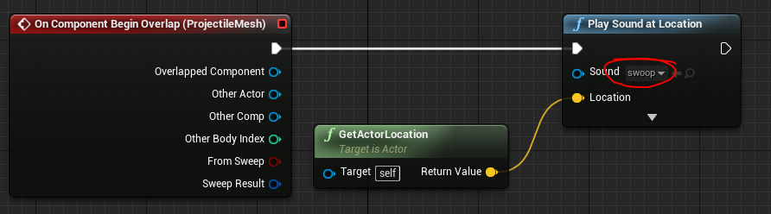
94. When we run the game we may not hear the sound.
95. So select the Projectile mesh and in the details panel under collision check the GenerateOverlapEvents
96. 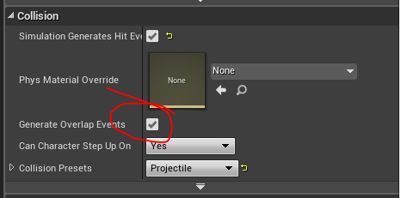
97. We need to turn on GenerateOverlapEvents on the permiable wall as well
98. So select the wall in the world and in details panle turn on GenerateOverlapEvents
99. Now we should hear the sound.